

HP OmniBook 4000C/CT
Familiarization Guide

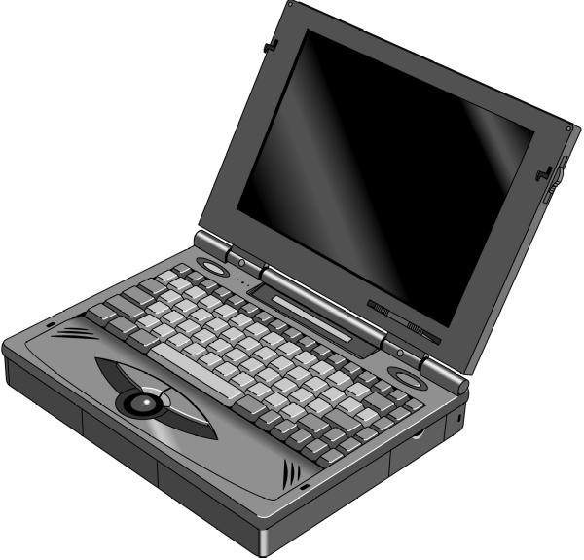
This guide is for experienced HP Response Center personnel, CEs, and reseller technicians, such as personnel who have already completed the HP Vectra PC family training course, or equivalent, and have at least six months of experience servicing the HP Vectra PCs.
It is a self-paced guide designed to train you to install, configure, and repair the OmniBook Notebook PC. You can follow it without having any equipment available.

Notice

In a continuing effort to improve the quality of our products, technical and environmental information in this document is subject to change without notice.

Last revision date: 3/10/1997 08:06:00 PM

Hewlett-Packard makes no warranty of any kind with regard to this material, including, but not limited to, the implied warranties of merchantability and fitness for a particular purpose. Hewlett-Packard shall not be liable for errors contained herein or for incidental or consequential damages in connection with the furnishing, performance, or use of this material.

Hewlett-Packard assumes no responsibility for the use or reliability of its software on equipment that is not furnished by Hewlett-Packard.

As an ENERGY STAR partner, HP has determined that these products meet the ENERGY STAR guidelines for energy efficiency.

All Certifications may not be completed at product introduction. Please check with your HP reseller for certification status.

This equipment is subject to FCC rules. It will comply with the appropriate FCC rules before final delivery to the buyer.

ENERGY STAR is a service mark of the U.S. Environmental Protection Agency. IBM and OS/2 are registered trademarks of International Business Machines Corporation. Pentium and the Intel Inside logo are registered trademarks of Intel Corporation. Photo CD is a registered trademark of Kodak Corporation. Microsoft, MS-DOS, and Windows are registered trademarks, and the Genuine Microsoft Products logo is a trademark of Microsoft Corporation in the United States of America and in other countries. Sound Blaster is a trademark of Creative Technology Ltd.

© Hewlett-Packard Company 1996.

All Rights Reserved. Reproduction, adaptation, or translation without prior written permission is prohibited except as allowed under copyright laws.

Printed in U.S.A.

F1081-90051
Table of Contents

Table of Figures
OmniBook Product Comparisons
Size Closed
Weight
OmniBook 4000 Series: Product Features
Description
Models
Accessories
What comes in the box
Microprocessor
Bus Architecture
Memory
Mass storage
Flexible disk drive
Built-in I/O
Display/video
TFT Display Quality
User interface
Power
External battery charger
Automobile adapter
NiMH battery pack
AC adapter
Accessory Slots
Audio Systems
Operating environment
Storage environment
Environmental Testing
BIOS
Software and Operating System
Supported Operating Systems
Security
Password Decode
Password Decode Policy
Notebook Hardware Structure
Field Replaceable Assemblies
Installing memory (End User Replaceable)
Battery Module and Floppy Disk Drive Module (End User Replaceable)
Hard Disk Drive (End User Replaceable)
Small parts (End User Replaceable)
Icon Assembly and Display Module (HP Authorized Support Providers Only)
Palm Rest Assembly and Track Ball Assembly (HP Authorized Support Providers Only)
Keyboard Assembly (HP Authorized Support Providers Only)
Power Board (PCA Assy PK-DC) (HP Authorized Support Providers Only)
Upper Case, Sound Board (PCB Assy PK-688/PK-AUD), and PCA Display Connect PK-LSP (HP Authorized Support Providers Only)
Keyboard Grounding Plate, CPU, and System Board (HP Authorized Service Providers Only)
Enhanced Port Replicator (Exchange Assembly)
Troubleshooting Tips:
Configuration and Setup
Main Configuration Screen
Power Screen
Power Configuration
Power Conservation Mode
Power Defaults
System Configuration
Input/Output Configuration
Printer port
Disk Configuration
Audio Configuration
Troubleshooting and Repair
Known Hardware Issues
OmniBook Self-Test
First POST: BEEP CODES
Last POST: DISPLAY CODES
PhoenixBIOS POST Messages (Power On Self Test)
Appendix A: Part Numbers
Appendix B: Additional Resources

Table of Figures
Figure 1 - Memory Doors, Modules, and Slots
Figure 2 - Floppy Drive and Battery
Figure 3 - Hard Disk Drive
Figure 4 - Display Screws
Figure 5 - Icon Assembly
Figure 6 - Display Removal
Figure 7 - Lower Case Screws
Figure 8 - Palm Rest and Track Ball Assemblies
Figure 9 - Keyboard and Sound Board
Figure 10 - Upper Case and Display Connect
Figure 11 - System Board and Keyboard Grounding Plate

OmniBook Product Comparisons
 | HP OmniBook 5000 | HP OmniBook 4000 | HP OmniBook 600
Size Closed | 29.5 x 22.6 x 4.9 cm  (11.6 x 8.9 x 1.93 in) | 29.5 x 22.6 x 4.9 cm  (11.6 x 8.9 x 1.93 in) | 18.49 × 28.24 × 3.99 cm  (7.28 × 11.12 × 1.57 in)
Weight | 3.08-3.18 kg (6.8-7 lb) | DSTN (C)  3.13 kg (6.9 lb)  TFT (CT):  3.27 kg (7.2 lb) | 1.72 kg (3.8 lb)
Processor | 75-, 90-, or 120-MHz Intel Pentium® processor | 50-Mhz Intel 486DX2, or 75-, 100-MHz Intel 486DX4 | 50- or 75-MHz Intel 486DX2
Bus Architecture | 32-bit PCI bus | ISA bus | ISA bus
Cache | some models include: 256-KB external L2 cache | No L2 cache | No L2 cache
Display | 10.4-inch diagonal:  VGA (C/CT): 640 x 480 x 65,536 colors (DSTN or TFT)  SVGA (CTS): 800 x 600 x 256 colors (TFT)  PCI local bus video; 1.5-MB video RAM  SVGA-out supports VGA & SVGA monitors (up to 1024 x 768 x 256 colors) | 10.3-diagonal DSTN (up to 256 colors) or  10.4-inch diagonal TFT (up to 65,536 colors)  VGA: 640 x 480  Local bus video; 1-MB display RAM  SVGA-out supports VGA & SVGA monitors (up to 1024 x 768 x 256 colors) | 8.6-diagonal DSTN or  9.5-inch diagonal TFT  640×480 backlit color VGA displays  64K colors from a 262K color palette  VGA-out supports VGA and SVGA monitors (up to 1024×768×256 colors)  Accelerated local bus video with 1-MB VRAM
Power | 14.4Vdc Rechargeable Lithium-Ion or NiMH battery  Battery life (approximate with one battery): 2 to 3 hrs  Battery recharges to high level in 4 hrs using AC adapter while PC is on or off  2-minute low-battery warning  AC adapter 100 to 240 Vac (50 to 60 Hz) input; 12 Vdc, 3.3 A output  Instant-on maintains computer in ready-to-work state for weeks on a full charge; returns you to your application or file instantly | 14.4 Vdc rechargeable NiMH battery pack  Battery life (approximate):  3-4 hrs on DSTN DX2/50  2-3 hrs on TFT DX4/100  AC adapter 100 to 240 Vac (50 to 60 Hz) input; 21 Vdc,1.35 A output  Suspend-resume power management. | 9.6 Vdc rechargeable NiMH or Lithium Ion battery  Battery life up to 3.0-3.5 hours.  Battery pack recharges to high level in less than 2 hours using AC adapter  2-minute (or less) low-battery warning  AC adapter 100 to 240 Vac (50 to 60 Hz) input; 12 Vdc, 2.5 A output  Instant-on maintains computer in ready-to-work state for months on a charge. Turn it on again, and you’re instantly back where you were.
Removable Modules | Floppy disk drive (can be replaced with a second battery for double battery life)  Hard disk drive  RAM  Battery | Floppy disk drive (can be replaced with a second battery for double battery life)  Hard disk drive  RAM  Battery | Hard disk drive  RAM  Battery
Mass Storage | 540-MB, 810-MB, or 1.2-GB hard disks | 260-, 340-, 520-, or 810-MB hard disk options | 170, 260, or 340 MB hard disk drive
RAM | 8- or 16-MB Models  upgradable to 64 MB  8-, 16-, or 32-MB RAM cards | 4-, 8-MB, or 16-MB RAM models  upgradable to 32 MB | 4-, 8-, 16- or 24-MB RAM models  upgradable to 32MB (CT) 20MB or 24MB (C).
Audio | 16-bit with Sound Blaster® and MIDI support  Stereo sound via two built-in speakers | 16-bit, Sound Blaster-compatible  Stereo sound via two built-in stereo speakers | Microsoft® Windows® sound in CT.  Two built-in speakers (not stereo sound)
Input/Output | 9-pin, 115,200 - b/s, RS-232 port  25-pin EPP and ECP parallel port  SVGA-out (up to 1024 x 768 x 256); VGA-out (640 x 480 x 65,536 colors)  115,200-baud, bidirectional infrared  Expansion bus connector  SCSI-2 port  NTSC/PAL video-out port  Keyboard/mouse port  Headphone/stereo-out port  Stereo-in and microphone ports  MIDI/joystick port | 9-pin, 115,200 - b/s, RS-232 port  25-pin EPP and ECP parallel port  SVGA-out (up to 1024 x 768 x 256)  115,200 - baud, bi-directional infrared  Expansion bus connector  Keyboard/mouse port  Headphone/stereo-out port  Microphone port  Stereo-in port | 9-pin, 115,200 - b/s, RS-232 port  25-pin bidirectional parallel port  SVGA-out (up to 1024 × 768 × 256)  115,200 - baud, bidirectional infrared  Enhanced port replicator connector  Floppy drive port
Expandability | One Type III PCMCIA slot (or use as two Type II slots) with 3.3-V or 5-V support  ISA-based slots, and parallel, serial,  SVGA-out (up to 1024 x 768 x 256),  keyboard, PS/2 mouse, MIDI/joystick, audio, and SCSI-2 ports | One Type III PCMCIA slot (or use as two Type II slots)  Enhanced port replicator with parallel, two serial, SVGA-out (up to 1024 x768), keyboard, PS/2 mouse, and SCSI ports; and PCMCIA slot (concurrent Type II and Type III) | One Type III PCMCIA slot (or use as two Type II slots)  External ultra-thin floppy disk drive (included with product)  Enhanced port replicator with EPP parallel, serial, VGA-out (up to 1024 × 768), keyboard, PS/2 or Microsoft® mouse, and SCSI ports; external floppy connector; and optional HP EtherTwist LAN card slot
Pre-installed Software | Microsoft Windows 95  or  Microsoft Windows for Workgroups 3.11 *  MS-DOS® 6.22  Plug and Play BIOS  HP PIM | Microsoft Windows for Workgroups 3.11  MS-DOS 6.2  Laplink Remote Access  Easy connection to your desktop PC, network and desktop printers; works via cable or infrared. | Microsoft Windows  for Workgroups 3.11  MS-DOS 6.22  Upgrade easily to Windows 95  Plug and Play BIOS  LapLink Remote Access  Appointment Book  HP Financial Calculator  Phone Book  IrDA infrared printing driver
Security Features | 2-level password protection  PC ID (tattooing)  Kensington lock slots | User password  Kensington lock slots | User password  Kensington lock slots
OmniBook 4000 Series: Product Features

Description | Advanced performance with flexibility, exceptional user comfort, all-day use and easy access to peripherals.
Models | This is a complete list of all the standard Omnibook models ever made available. Factory special options are not included in this listing. Many of these models are now obsolete.  Refer to the Hewlett-Packard Corporate Price List for cuurently available models and options.
 |  | Product |  | Description | Part Number
 |  | HP OmniBook 4000C |  | DX2/50MHz; 260MB Hard Drive | F1081A
 |  | HP OmniBook 4000C |  | DX2/50MHz; 340MB Hard Drive | F1082A
 |  | HP OmniBook 4000C |  | DX2/50MHz; 520MB Hard Drive | F1083A
 |  | HP OmniBook 4000CT* |  | DX4/75MHz; 340MB Hard Drive | F1157A
 |  | HP OmniBook 4000CT* |  | DX4/75MHz; 520MB Hard Drive | F1158A
 |  | HP OmniBook 4000CT* |  | DX4/75 MHz; 810MB Hard Drive | F1159A
 |  | HP OmniBook 4000C |  | DX4/100MHz; 340MB Hard Drive | F1086A
 |  | HP OmniBook 4000C |  | DX4/100MHz; 520MB Hard Drive | F1087A
 |  | HP OmniBook 4000C |  | DX4/100MHz; 810MB Hard Drive | F1096A
 |  | HP OmniBook 4000CT* |  | DX4/100MHz; 340MB Hard Drive | F1088A
 |  | HP OmniBook 4000CT* |  | DX4/100MHz; 520MB Hard Drive | F1089A
 |  | HP OmniBook 4000CT* |  | DX4/100MHz; 810MB Hard Drive | F1097A
 |  | HP OmniBook 4000CT* |  | DX4/100MHz; 810MB Hard Drive with 16MB RAM | F1160A
 |  |  | * Indicates TFT display
 |  |  | (Note: All others have 8-MB RAM except, F1081A with 4MB RAM and F1160A, which has 16MB RAM)
Accessories | Description |  |  |  |  |  |  |  |  | Part Number
 | 4-MB RAM expansion card |  |  |  |  |  |  |  |  | F1076A
 | 8-MB RAM expansion card |  |  |  |  |  |  |  |  | F1077A
 | 16-MB RAM expansion card |  |  |  |  |  |  |  |  | F1078A
 | 260-MB Hard Disk Drive |  |  |  |  |  |  |  |  | F1091A
 | 340-MB Hard Disk Drive |  |  |  |  |  |  |  |  | F1092A
 | 520-MB Hard Disk Drive |  |  |  |  |  |  |  |  | F1093A
 | 810-MB Hard Disk Drive |  |  |  |  |  |  |  |  | F1032A
 | 3.5 inch Floppy Drive Module |  |  |  |  |  |  |  |  | F1079A
 | AC Adapter |  |  |  |  |  |  |  |  | F1072A
 | NiMH Battery Pack Module |  |  |  |  |  |  |  |  | F1073A
 | External Battery Charger (Charges up to two batteries concurrently) |  |  |  |  |  |  |  |  | F1074A
 | Automobile Adapter |  |  |  |  |  |  |  |  | F1075A
 | Enhanced Port Replicator |  |  |  |  |  |  |  |  | F1090A
What comes in the box |  |  | OmniBook 4000 mainframe  Battery pack  User documentation: manuals, support material, registration card  Companion/utility disks  AC adapter (P/N: F1072A), localized power cord  Brochures for OmniBook accessories and Deskjet 320
Microprocessor |  |  | Intel486 DX2 50-MHz  Intel486 DX4 75-MHz  Intel486 DX4 100-MHz
Bus Architecture |  |  | ISA, Video local Bus
Memory |  | Main Memory |  |  |  | DX2/50 MHz, Model 260 (F1081A)  DX4/100 MHz, Model 810 (F1160A)  All other models |  |  | 4MB RAM  16MB RAM  8MB
 |  |  |  |  | Max Possible RAM |  |  | 32MB
 |  |  |  | Type of memory boards |  |  | HP Proprietary boards, 2 user accessible slots on the bottom case.
 |  |  |  | Expansion Memory board options |  |  | 4-MB (HP # F1076A)  8-MB (HP # F1077A)  16-MB (HP # F1078A)
 |  |  |  | Cycle time |  |  | 70ns
Mass storage |  |  |  | The hard disk drive can be removed by the user for easy upgrades. The hard drive is located on the bottom case and with the removal of one screw the hard drive can be replaced.  Hard drive manufacturer: Toshiba for all capacities
Flexible disk drive |  |  |  | Internal 3.5 inch, 1.44-MB flexible disk drive is standard on all models. The flexible disk drive can be easily removed by the user and replaced with an additional battery pack to double battery life. This is part of the modularity features of the OmniBook 4000.  Manufacturer: Canon (subject to change)
Built-in I/O |  |  |  | 25 pin bi-directional ECP an EPP parallel port  SVGA out (up to 1024 x 768 x 256 colors) with simultaneous viewing  115,000-b/s bi-directional infrared port.  Expansion Bus Connector for connecting to enhance port replicator (F1090A)  6-pin mini-DIN keyboard or PS/2 mouse  Headphone/stereo-out port  Microphone port  Stereo-in port
Display/video |  |  |  | The OB4000 DSTN may report the display RAM to be 1024KBs, however, it is 512KB. Later versions have corrected this. It is not a hardware problem but a reporting problem.  Display RAM is not upgradable.  Display Manufacturer: Hitachi  Video graphics controller chip: Western Digital 90c24 rocket chip.  External video resolution (both types): Supports VGA/SVGA external monitors with up to 1024 x 768 x 256 colors in noninterlaced mode.  Auto detection of external monitor without rebooting  Note: Includes option to simultaneously display external video and notebook display.
TFT Display Quality |  |  |  | TFT display manufacturing is a high precision but imperfect technology and manufacturers cannot currently produce large displays that are cosmetically perfect. Most if not all TFT displays will exhibit some level of cosmetic imperfection. These cosmetic imperfections may be visible to the customer under varying display conditions and can appear as bright, dim or dark spots.
 |  |  |  | This issue is common across all vendors supplying TFT displays in their products and is not specific to the HP OmniBook display.
 |  |  |  | The HP OmniBook TFT displays meet or exceed all TFT manufacturer's standards for cosmetic quality of TFT displays. HP does not warrant that the displays will be free of cosmetic imperfections.
 |  |  |  | TFT displays may have a small number of cosmetic imperfections and still conform to the display manufacturers cosmetic quality specifications.
 |  |  |  | Here are some guidelines to use in determining what action to take on a customer complaint of cosmetic imperfection in their TFT display:
 |  |  |  | 1. The unit should be viewed in the customer's normal operating condition.
 |  |  |  | This means if the customer uses the unit predominately in DOS, or Windows, or in some other application or combination of applications, that is where the determination shall be made. Self test is not a normal operating condition and is not a sufficient tool to interpret display quality.
 |  |  |  | 2. In the customer's normal operating mode:
 |  |  |  | a. If 4 or more variant pixels appear clustered in the area approximated by a thumbprint on the display surface, then the display should be considered for replacement.
 |  |  |  | b. On OmniBook 4000CT models, if more than 30 total pixels anywhere on the display are bad, then the display should be considered for replacement. On OmniBook 600CT and OmniBook 5000CT models, if more than 15 total pixels anywhere on the display are bad, then the display should be considered for replacement.
 |  |  |  | These are the only conditions in this guideline that may call for a replacement due to a defect in material or workmanship based on the HP Limited Warranty Statement.
 |  |  |  | 3. If a display is considered for replacement, it should be clear to the customer that cosmetic variations on the replacement display may also exist, and may require the customer to use a work-around to obscure the cosmetic imperfection.
 |  |  |  | 4. Customers with cosmetic-based complaints only, that do not conform to the above conditions and tests will not normally be considered for display replacement. It will be left to the judgment of the HP-responsible person who, in working with the customer, to identify work-arounds that are reasonable and appropriate for the individual customer. Customers who must have a more perfect display solution should consider switching to an OmniBook with a DSTN display.
 |  |  |  | We expect over time that the industry will continue to improve in their ability to produce displays with fewer inherent cosmetic imperfections and will adjust our HP guidelines as the improvements are implemented.
User interface |  |  |  | Keyboard: 85-key touch-type keyboard with embedded numeric keypad and 12 Fn keys. Wrist pad provides comfort for extended keyboard use. External 6-pin mini-DIN interface for external keyboard connection. (HP external keyboard (101-key) Part number C3756A)  Pointing device: Built in 25MM trackball positioned in the center of the wrist pad for easy access and comfort. Industry compliant to maintain software compatibility.  Optional pointing devices: Includes 6-pin mini-DIN interface for external PS/2 mouse connection. Also supports serial mouse connection.
Power |  |  |  | Battery type: Removable 14.4-Vdc rechargeable NiMH. NiMH battery does not require complete discharge before recharging. There is no "memory" effect that reduces battery life.
Battery Life; rundown (approx.):
3-4 hrs on DSTN DX2/50
2-3 hrs on TFT DX4/100
 |  |  |  | Recharge time: Approx. 75 minutes in suspend mode or off position. The battery trickle charges while the unit is turned on. It takes several days to gain a full charge while trickle charging.
Power |  |  |  | Low battery signals: Low battery warning at 10 percent of full charge, followed by save to hard disk after five minutes.
 |  |  |  | Battery life can be doubled by installing second battery in place of the 3.5 " flexible drive. The OmniBook will recognize the additional battery and provide battery status of both batteries (can be installed hot).
 |  |  |  | Smart Battery: The OmniBook 4000 uses "Smart" battery technology. The battery itself contains an ASIC (Application Specific Integrated Circuit) that is able to continuously test and track the status of the battery. The OmniBook BIOS can then receive high-quality information about the battery condition directly from the hardware and not interrupt the CPU. The OmniBook 4000 no longer has to rely on software to determine the condition of the battery. The condition can be checked using two methods that receive information from the BIOS (CONFIGURATION [fn][f2], Windows Control Panel Power).
 |  |  |  | Energy S.T.A.R. compliant
 |  |  |  | AC Adapter: 100 to 240 Vac adapter (50 to 60 Hz) input; 21 Vdc, 1.35A output. Use only an HP F1072A AC adapter (the type shipped with the OmniBook). Using any other adapter could damage the OmniBook and void the warranty. Always plug it into a grounded outlet..
 |  |  |  | Power management options: Advanced; Standard; Off; Custom.
 |  |  |  | Optional power accessories from HP:
 |  |  |  | A fully charged NiMH battery in storage will loose 20% of its charge per month in storage.
External battery charger |  |  |  | Designed for desktop use. It has an internal power supply and plugs in to the wall. Works with 110/220 volts and 50/60Hz. It also has a power cord to plug into the OmniBook 4000.
 |  |  |  | Charges two additional batteries
 |  |  |  | HP part number: F1074A
Automobile adapter |  |  |  | HP part number F1075A
NiMH battery pack |  |  |  | HP part number F1073A
AC adapter |  |  |  | HP part number F1072A
Accessory Slots |  |  |  | User available PCMCIA Slots: 2 Type II or 1 Type III (version Two)
 |  |  |  | The PCMCIA slots are fully industry compatible and supports SystemSoft Card Services and Socket Service (2.1). The system will support a wide variety of PCMCIA cards.
 |  |  |  | PCMCIA controller chip manufacturer: Vadem 386.
Audio Systems |  |  |  | High performance audio: 16-bit stereo sound, Sound Blaster hardware compatible.
 |  |  |  | Two stereo speakers with acoustic chambers
Audio Systems |  |  |  | I/O: Headphone/stereo-out port; microphone port; Stereo-in port
 |  |  |  | IRQ default setting for soundblaster is 5.
 |  |  |  | Sound Manufacturer: ESS
Operating environment |  |  |  | Temperature:
 |  |  |  | DSTN display models: 41 to 104 degrees F (5 to 40 degrees C)
 |  |  |  | TFT display models: 50 to 104 degrees F (10 to 40 degrees C)
 |  |  |  | 90% relative humidity at 104 degrees F (40 degrees C) maximum
Storage environment |  |  |  | Temperature: -40 to 149 degrees F (-40 to 65 degrees C)  90% relative humidity at 149 degrees F (65 degrees C) maximum
Environmental Testing |  |  |  | ESD as per IEC-801-2, EN 55024-2  Drop testing: 1 drop flat onto all six faces from .75 meter  Also tests for altitude, magnetic & radiated susceptibility & interference, shock & vibration.  Note: These are the tests that HP designs notebook computers to meet. Due to normal variations in the components of individual machines, some machines will perform better and some won't perform as well. HP does not guarantee that every notebook computer will meet these specifications.
BIOS |  |  |  | Plug and Play BIOS stored in EEPROM  User Upgradable via floppy drive  A corrupt BIOS that prevents the machine from booting requires a system board replacement. The BIOS can be corrupted by interrupting the BIOS upgrade in the middle of the process.
Software and Operating System |  |  |  | Microsoft Windows for Workgroups 3.11  MS-DOS 6.2
 |  |  |  | Easy upgrade to Windows 95
 |  |  |  | Laplink Remote Access for easy connection to desktop PC, network printers, and other OmniBooks
Supported Operating Systems |  |  |  | MS DOS version 6.22*  Microsoft Windows for Workgroups 3.11*  Microsoft Windows 95*  Microsoft NT workstation 3.51**  OS/2® version 3.0**  * Supported to the application level. ** Only setup and configuration supported.
Security |  |  |  | Physical security from Kensignton Lock  System password: When the password setting is enabled, a window will pop-up to allow the user to enter the old password, enter a new password and to verify the new
Password Decode |  |  |  | If the user forgets the system password, there is a master password that will unlock the Omnibook. The user calls Technical Support to determine this master password as follows:  1. Support will tell the user the keys to type at the password entry screen: [alt][shft][f10]  2. The Omnibook generates and displays an encoded master password. This is displayed under the normal password entry area. At this point, this is the only password that will unlock the Omnibook unless the user presses [ESC] to remove the encoded master from the password entry screen. Then the user's stored password can be entered.  3. The user reads the encoded master password to Support.  4. Support runs a program that decodes the encoded password, and reads the decoded password (alphanumeric) to the user.  5. The user types in the decoded password.  6. Omnibook decodes the encoded master password it generated and compares it to the decoded password typed in by the user.  7. If the two passwords match, the Omnibook is unlocked. The forgotten password is automatically erased. Support can then guide the user through the process of entering a new password.  8. If the two passwords do not match, the previous sequence must be repeated until the user correctly enters a master password.  The encoded master password is an eight-character alphanumeric sequence that the Omnibook generates at random every time the appropriate keys are pressed in the password entry screen. Because it is generated randomly, a master password can only be used to unlock the Omnibook once. If the user forgets the password at another time, it will require another call to Support. (If the user presses the appropriate keys by mistake, pressing [ESC] will allow entering the stored password.)
Password Decode Policy |  |  |  | The password descramble programs for the HP OmniBook PCs are protected as HP Company Private information. They may not be copied, backed-up, printed or distributed. There are only six official copies of each program.  In addition to protecting the program itself, it's use is also controlled. Hewlett-Pakard and authorized support providers must ensure with written evidence that the OmniBook that is being "descrambled" is actually in the hands of the unit's actual and current owner. This requires a sales receipt showing the unit serial number and owner's name, or a written statement from the owner attesting that they are the owner of the unit. The statement can be a FAX copy of the document. The fact that the unit is in the hands of an HP representative on the behalf of the customer is not evidence of ownership. In addition, HP will not descramble a unit for any non-owner, even if it involves law enforcement agencies. If you receive such a request, you should notify management and HP Corporate Legal immediately. (These requests may require a court order prior to our participation.)  Further, you must log the name, serial number and date of the running of the descramble program, and file the written backup with the log. The log and backup is subject to standard record's retention process and review.  The final issue relating to descramble of passwords is that HP cannot provide information to users that would assist them in improperly descrambling a password and opening a unit.
Notebook Hardware Structure
Field Replaceable Assemblies

Installing memory
(End User Replaceable)

The OmniBook 4000 family has two memory locations for expanding system RAM. The memory location on the side of the OmniBook that has the battery also has the factory RAM module installed. To add an additional 8MB or 16MB of RAM, use the location on the other side of the unit near the floppy drive. If the base unit has 4MB or 8MB of memory, and you want to expand the memory to more than 20MB or 24MB, then the original 4MB or 8MB module must be replace with a larger module.
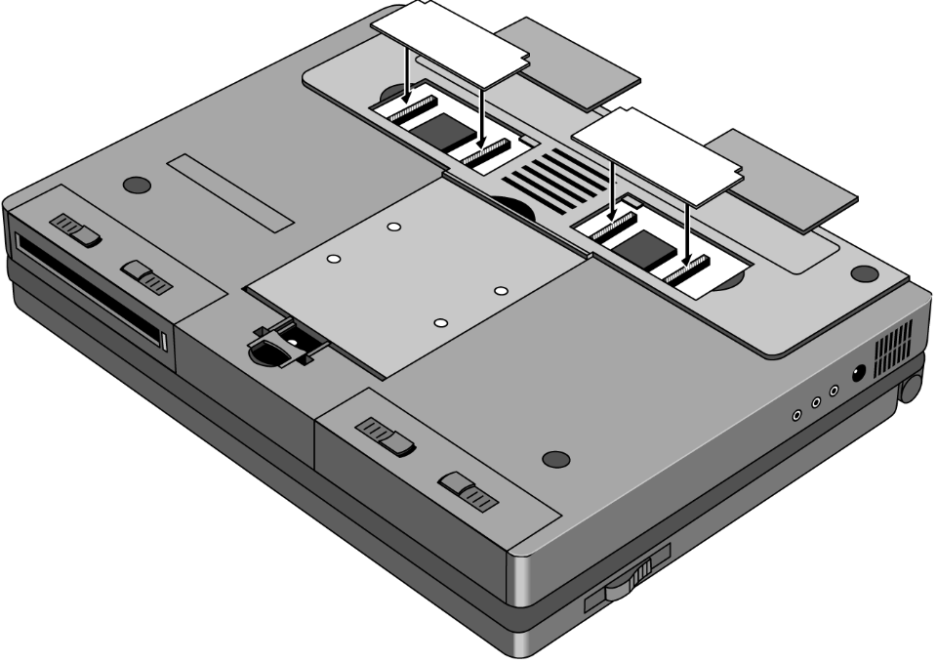
Figure 1 - Memory Doors, Modules, and Slots
Battery Module and Floppy Disk Drive Module
(End User Replaceable)

The Battery and Floppy Disk Drive Modules are user replaceable. A second Battery Module may be installed in the Floppy Disk Drive Bay. This doubles the battery life of the OmniBook 4000.
To remove either module, turn the OmniBook over. Squeeze the two levers together and slide the module forward.
Reverse the procedure to install a new Battery or Floppy Disk Drive Module.

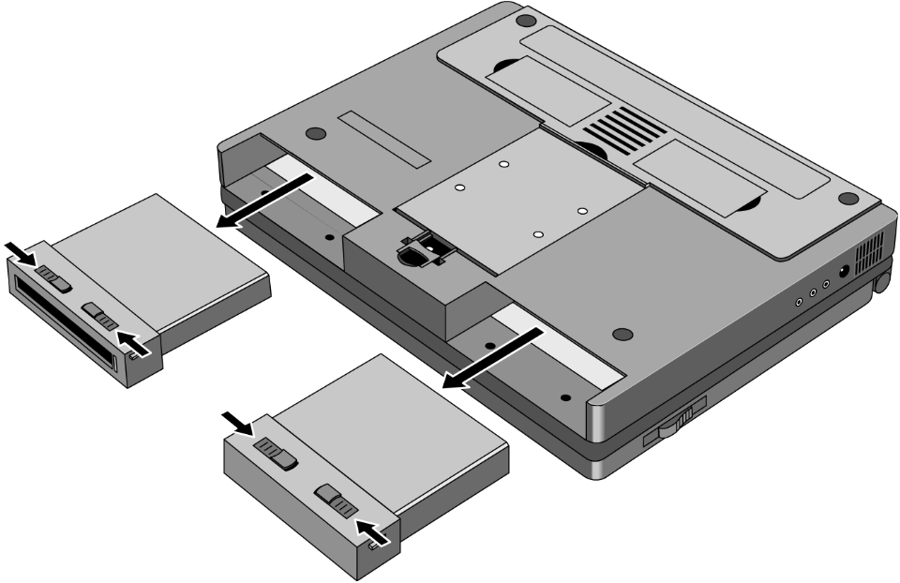
Figure 2 - Floppy Drive and Battery
Hard Disk Drive
(End User Replaceable)

The Hard Disk Drive Module is user replaceable.
To remove the Hard Disk Drive Module, remove the screw under the latch on the hard drive. Push the Hard Drive Module Forward - do not pull on the latch - it is not strong enough, use the back edge of the module in front of the depression in the bottom case instead.
Reverse the procedure for installation.

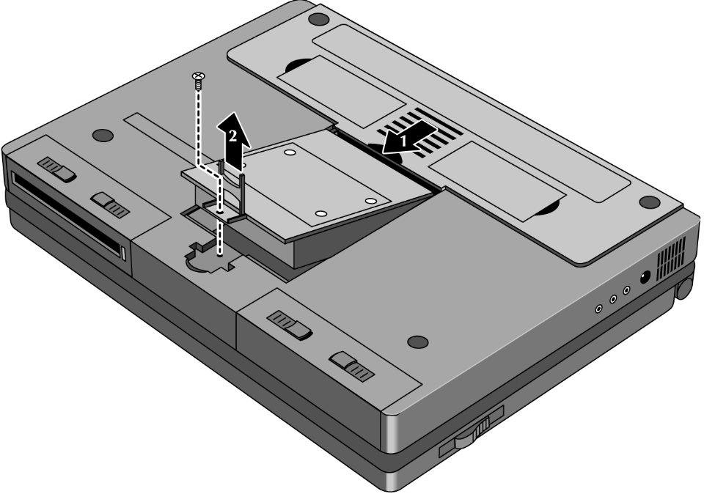
Figure 3 - Hard Disk Drive
Small parts
(End User Replaceable)

The I/R lens, expansion door, I/O door, Rubber feet, memory doors, and PCMCIA door are all replaceable.
The I/R lens snaps in and out from the inside of the I/O door.
To remove the I/O door, open it fully. Flex the door so that the center hinge separates from the backcase. Continue to flex until side pins clear holes in back case. To reassemble, simply reverse the procedure.
The expansion door is removed by opening it fully and flexing it in the middle until the pins in the backcase disengage from the slots in the side of the door. To reassemble, reverse the procedure.
The rubber feet are adhered to the bottom case with adhesive.
The PCMCIA door is remove in the same manner as the expansion door.
Icon Assembly and Display Module
(HP Authorized Support Providers Only)

To remove the display module on the OmniBook 4000C and CT turn the unit over and withdraw the two Phillips screws from the bottom back corners of the unit (see diagram below). This is not required if only the ICON assembly is to be removed.
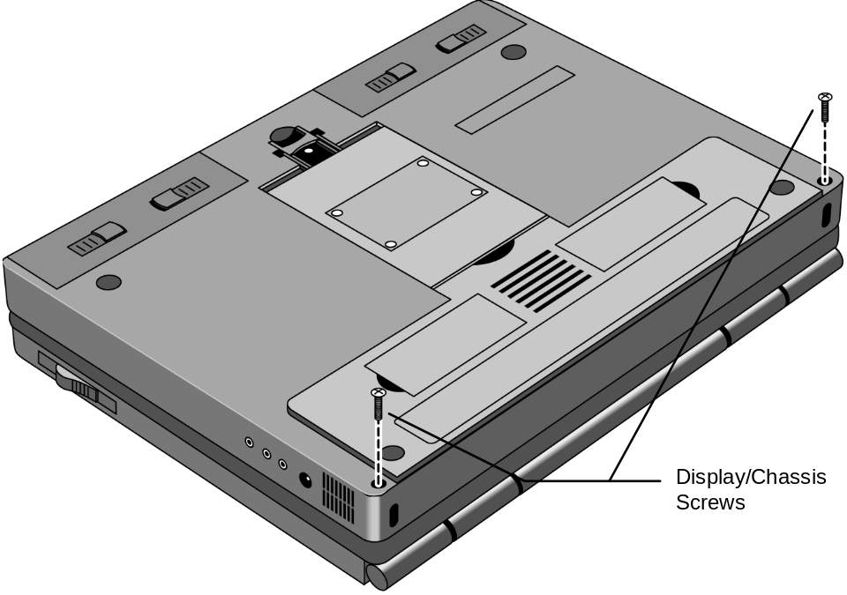
Figure 4 - Display Screws

Turn the unit right side up and remove the Icon assembly by placing the thumbs on each edge of the assembly and pushing lightly (see diagram below). The front edge of the Icon Assembly will lift up slightly.

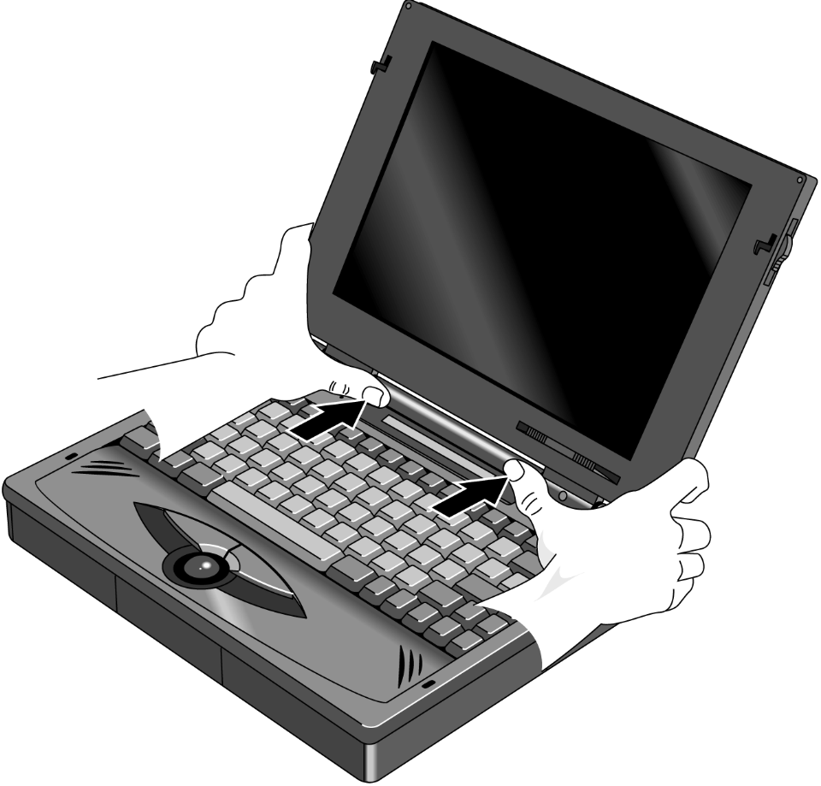
Figure 5 - Icon Assembly

Lift the display straight up about 1 inch. The Icon Assembly will lift up with the display. Move the Icon assembly out of the way. The cable from the Icon Assembly to the PC board does not need to be removed if only the display is being removed. Otherwise, slide the connector sleeve foward to remove the Icon Assembly cable.
Next, remove the two cables attaching the display module to the PC board. Lastly, remove the two screws attaching the grounding straps to the PC board. The display can now be removed the rest of the way.

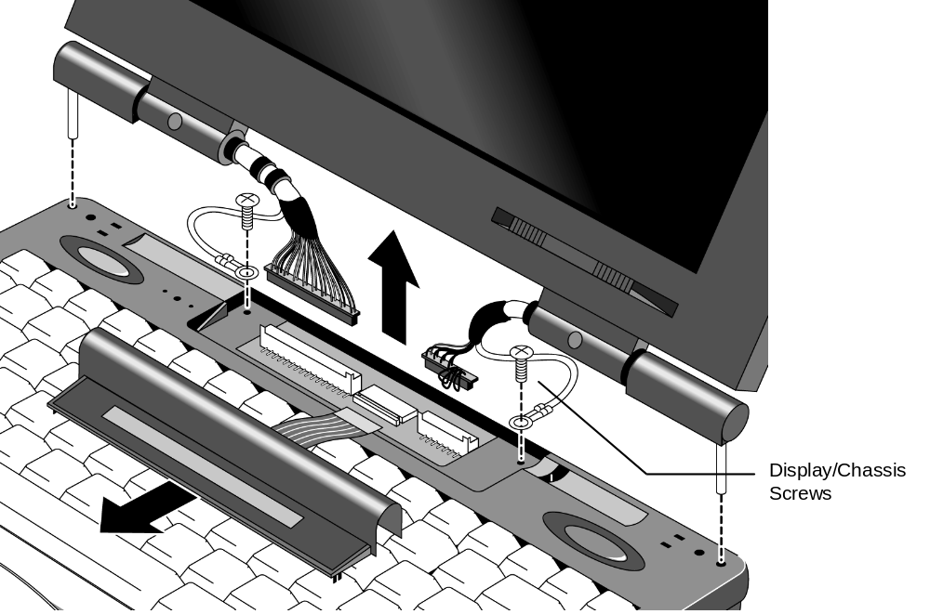
Figure 6 - Display Removal

To reinstall the display module or Icon Assembly, just reverse the above procedure. When reinstalling the Display Module, make sure that the two posts on either side of the display line up parallel with their slots in the top case. If they are not parallel, the post will get caught inside the top case before the display is seated completely. If this happens, remove the display and line the posts up properly. Also take care that the Icon Assembly flex cable is tucked inside of the “tunnel” of the Icon Assembly. This will prevent the cable from crimping and possibly malfunctioning.
Palm Rest Assembly and Track Ball Assembly
(HP Authorized Support Providers Only)

Before removing the Palm Rest Assembly or Track Ball Assembly, the battery and the floppy disk drive assembly (a second battery may be installed in to the floppy drive bay) must be removed. See instructions for removal of these two modules.
In the floppy disk drive and battery bays are four Phillips screws, two in each bay. Remove these four screws while the unit is upside down (see illustration below).

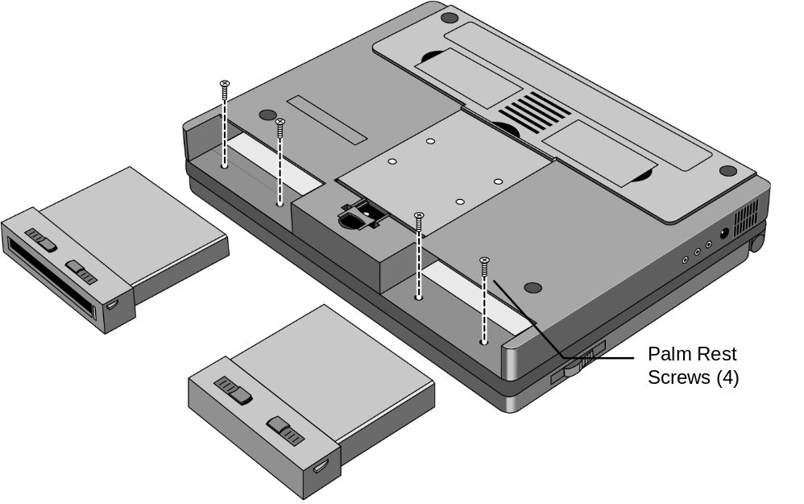
Figure 7 - Lower Case Screws

Turn the unit right side up, open the lid and lift up on the palmrest. Disconnect the cable attaching the palmrest to the track ball assembly.
To remove the track ball assembly, disconnect the Track Ball Assembly cable and remove the one screw that holds the Track Ball Assembly in place. The Track Ball Assembly then lifts out.

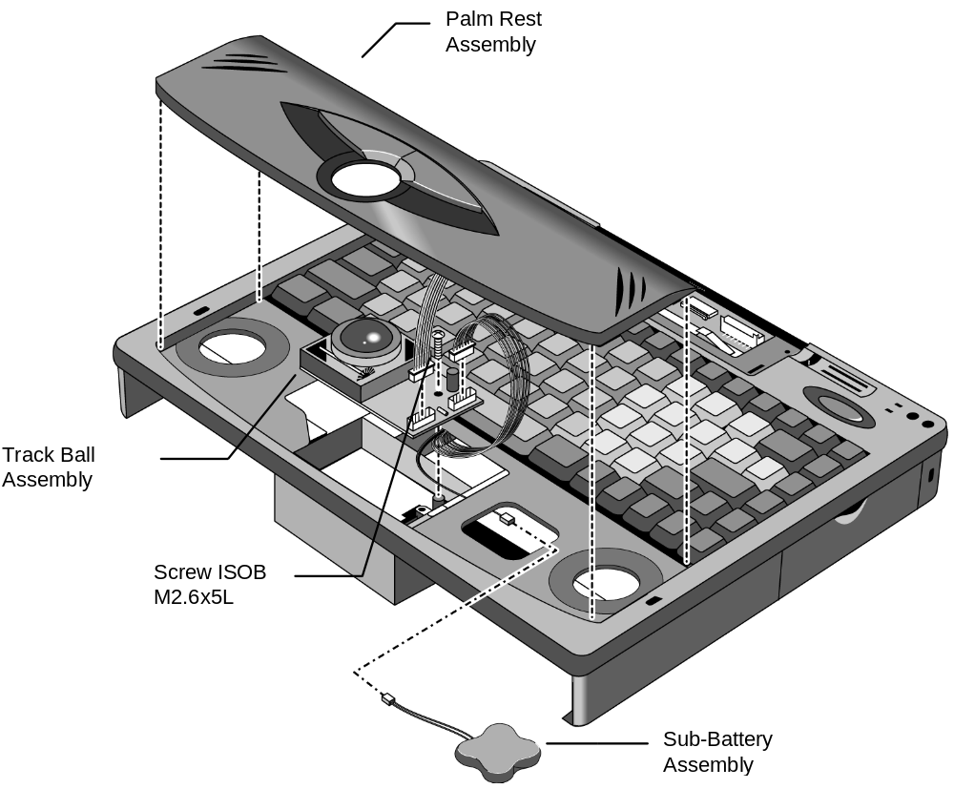
Figure 8 - Palm Rest and Track Ball Assemblies

Reverse the procedure to install a new Palm Rest Assembly or Track Ball Assembly.
Keyboard Assembly
(HP Authorized Support Providers Only)

Required Equipment:
- Phillips Screwdriver

Components to Remove Prior to Keyboard:
- HDD, FDD, and Battery
- Palm Rest Assembly (may remain connected)
- Sound Board (PCB Assy PK-688/PK-AUD) (partial removal)

Removal Procedure:
- Follow the instructions for removing Battery, Floppy Disk and Hard Drive.
- Follow the Palm Rest Assembly Removal Procedure. Note the Track Ball does not need to be removed and the Palm Rest may be lifted out without being disconnected.
- The keyboard can then be lifted out by gently prying up on the front edge.
- To gain access to the Keyboard flex cables, the Sound Board must be removed (see Figure 9). To remove the Sound Board, lift up on the sides of the board. Note, the Sound Board cannot be completely disconnected at this point - the Upper Cover must be removed to gain full access to the Sound Board.
- Disconnect the Keyboard flex cables from the zero force insertion slots.

Replacement Procedure:
- Reverse the procedure to install a new keyboard.

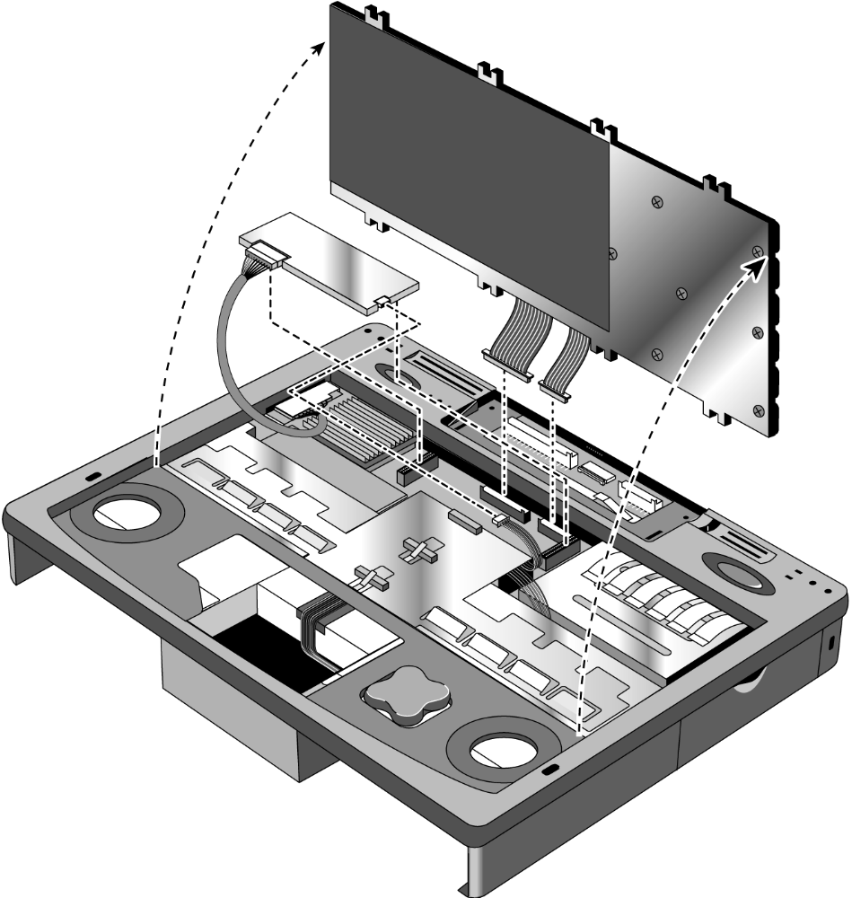
Figure 9 - Keyboard and Sound Board
Power Board (PCA Assy PK-DC)
(HP Authorized Support Providers Only)

Required Equipment:
- Phillips Screwdriver

Components to remove prior Power Board (PCA Assy PK-DC):
- HDD, FDD, and Battery
- Palm Rest Assembly (may remain connected)
- Keyboard (may remain connected)

Removal Procedure:
- Remove Battery, Floppy Disk Drive, and Hard Disk Drive.
- Follow the Palm Rest Assembly Removal Procedure to remove this component. Note, the Palm Rest only needs to be lifted out; it may remain connected.
- Follow the Keyboard Removal Procedure. Note, the Keyboard only needs to be lifted out; it may remain connected.
- Remove the Power Board by gently rocking back and forth. See Figure 10 for component location.

Replacement Procedure:
- Simply reverse the above Removal Procedure.

Upper Case, Sound Board (PCB Assy PK-688/PK-AUD), and PCA Display Connect PK-LSP
(HP Authorized Support Providers Only)

Required Equipment:
- Phillips Screwdriver

Components to remove prior Upper Case, Sound Board (PCB Assy PK-688/PK-AUD), and PCA Display Connect PK-LSP:
- HDD, FDD, and Battery
- Icon Assembly and Display Module
- Palm Rest Assembly
- Keyboard Assembly
- Power Board (optional)

Removal Procedure:
- Remove Battery, Floppy Disk Drive, and Hard Disk Drive.
- Follow the Icon Assembly and Display Module Removal Procedure to remove these components.
- Follow the Keyboard Removal Procedure. Note, although the Sound Board cannot be completely removed at this point, it is strategic to disconnect the rightmost harness cable at this step (see Figure 9).
- Additional maneuvering space may be gained by removing the Power Board, however, it is not necessary to do so.
- Remove the ISOB M2x6L Screw located on the left side of the Upper Case. See Figure 10 for location of this component.
- Remove the Upper Case by gently prying up at the seam between the Upper Case and Lower Case. The Upper Case will then snap off.
- At this point, the Upper Case will still have the Sound Board and the Microphone Assembly attached. The Microphone can simply be disconnected from the Sound Board if necessary. The Sound Board may be affixed with a drop of glue to the Upper Case where the Audio Ports meet the plastic. The Audio Ports can be gently pried from the Upper Case plastic if necessary (see Figure 10). Note, that the Sound Board and Audio Ports are a single assembly.
- Next, remove the three (3) ISOB M2.6x5L screws from the LSP-M/B Shielding Plate and PCA Display Connect PK-LSP. See Figure 10 for locations of these components.
- The LSP-M/B Shielding Plate can now be removed.
- Remove the PCA Display Connect PK-LSP by gently rocking back and forth.

Replacement Procedure:
- Simply reverse the above Removal Procedure.
- Take note that to reinstall the Audio Ports onto the plastic of the Upper Case does not require a drop of glue. The one screw is sufficient.
- The LSP-M/B Shielding Plate fits between the plastic of the Lower Case and the strip of shielding affixed along the audio ports holes in the plastic of the Lower Case.

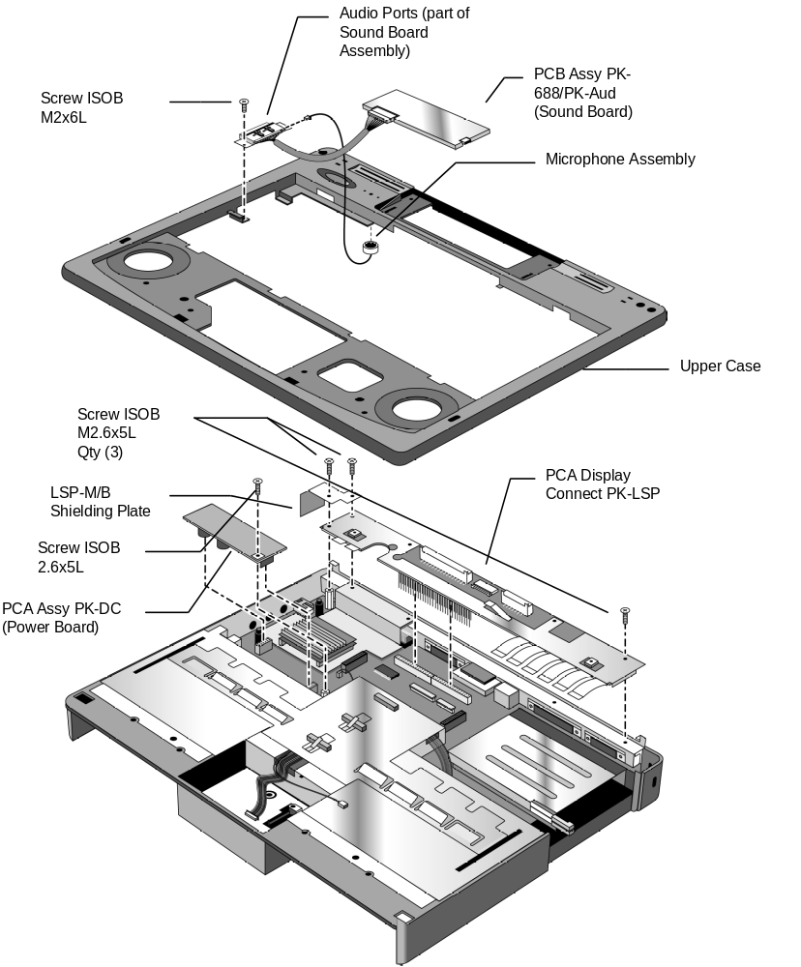
Figure 10 - Upper Case and Display Connect
Keyboard Grounding Plate, CPU, and System Board
(HP Authorized Service Providers Only)

Required Equipment:
- Phillips Screwdriver
- Nutdriver (5 mm or 3/16 in)

Components to remove prior Keyboard Grounding Plate, CPU, and System Board:
- HDD, FDD, and Battery
- Icon Assembly and Display Module
- Palm Rest Assembly
- Keyboard Assembly
- Power Board
- Upper Case, Sound Board, and Display Connect

Removal Procedure:
- Remove Battery, Floppy Disk Drive, and Hard Disk Drive.
- Follow the Icon Assembly and Display Module Removal Procedure to remove these components
- Follow the Palm Rest and Keyboard Assembly Removal Procedures to remove these components.
- Remove the Power Board by gently rocking back and forth.
- Remove the Upper Case, Sound Board, and Display Connect by following the corresponding Removal Procedure.
- Remove the K/B Grounding Plate by unfastening the three (3) ISOB M2.6x5L screws and one (1) 10mm standoff. See Figure 11 for locations of these components. Take note that the Track Ball and Sub Battery-M/B Harnesses must be threaded through the K/B Grounding Plate before it can be freely removed.
- The CPU may now be removed by gently rocking back and forth. Take care not to dislodge the heat sink from the top of the CPU. If needed, the CPU Shielding Plate may also be removed at this point.

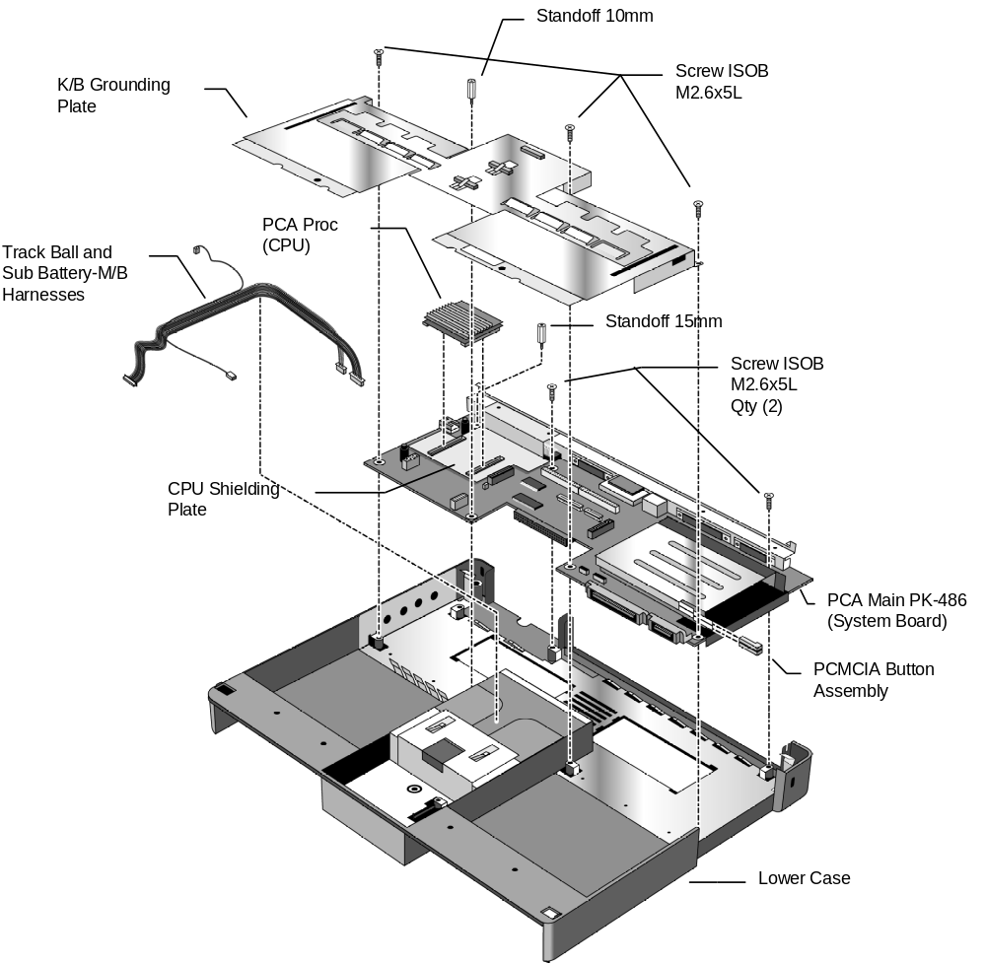
Figure 11 - System Board and Keyboard Grounding Plate
Enhanced Port Replicator
(Exchange Assembly)

The Enhanced Port Replicator (EPR) for the OmniBook 4000 contains no field replaceable components. If any component of the EPR is defective, the entire unit must be replaced.

Troubleshooting Tips:
- The OmniBook 4000 will only detect one pointing device at a time. Therefore, if an external mouse is connected to the EPR, the track ball will not be active.
- When an external mouse is detached, the pointing devices settings must be manually updated in the Setup for the change to be detected.
- The EPR PCMCIA slots do not receive power when the OmniBook is in Suspend mode.

Configuration and Setup
Main Configuration Screen

Pressing [fn][f2] invokes the BIOS setup and configuration utility. Users can check system configuration and changes settings using [f] keys from this screen. This is the most accurate place to check battery and system status. Pressing [f3] from this screen exits back to the current application.

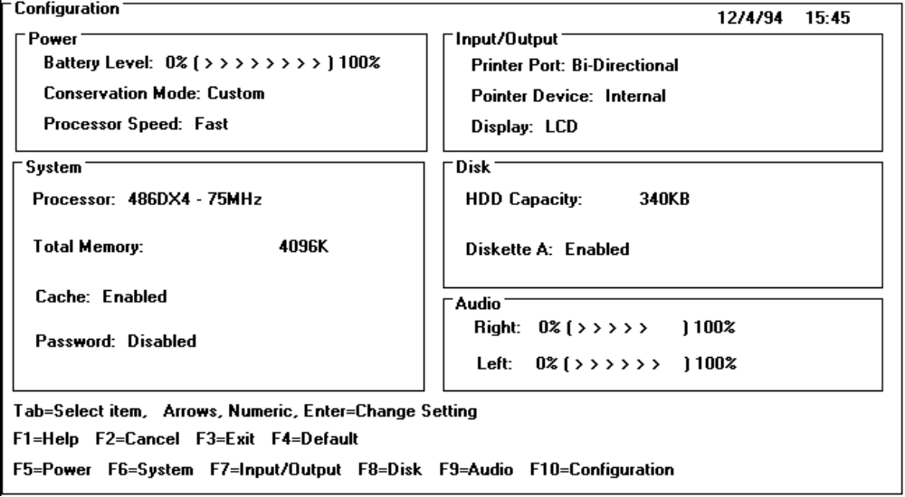
Power Screen

The power screen contains the current power level of the main and auxiliary battery. If there is no auxiliary battery, the text is dimmed (or in a passive color). Power conservation settings consists of the options shown. When Custom is selected, "suspend after", "hibernate after" and "HDD stop after" settings can be changed by the user (indicated again by the settings in brackets [ xxx ]). When any of the other selections are chosen by the user, the system will show the settings that are programmed by the system.
The hibernation setup area is shown to inform the user the size of the file used to save the RAM image to disk. There is no user selectable control in this area.

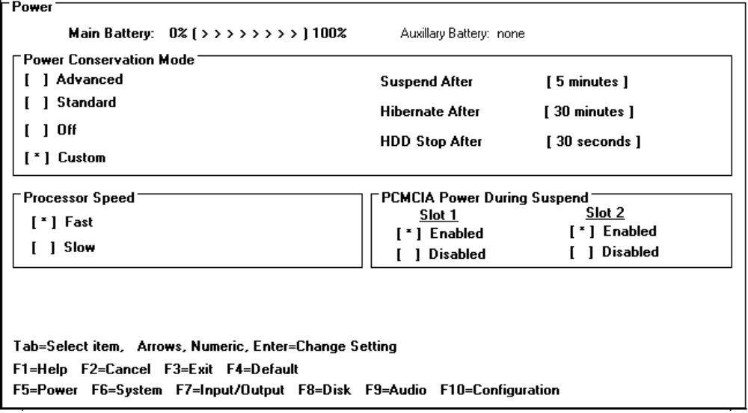
Power Configuration

To implement the power management capabilities, the following settings are set by the user from the power setup screen. The CPU doze will automatically occur and will not be user selectable.

Setting: | Parameters: | Default | Comments:
Power Conservation Mode | Advanced; Standard; Off; Custom | Advanced | In advanced mode the user can not change the settings, they are preset.
Suspend After | Disable; Time  (1 - 15 minutes) | 2 minutes | How long the system will stay in Run with (no activity) until it suspends. If disabled it will stay in Run.
Hibernate After | Disable; Time  (5 - 120 minutes) | 30 minutes | How long the system will be in the suspend state. If disabled it will stay in the suspend state.
HDD Stop After | Disable; Time  (0.5 - 15 minutes) | 1 minute | HDD will turn off, system has ability to run. HDD will spin up when access required.
Processor Speed | Fast; Slow | Fast
PCMCIA Power | Disable; Enable | Enable | Enable power to PCMCIA each slot during suspend.
Power Defaults

Advanced, Standard, Off and Custom, power conservation default values are:

 | Advanced | Standard | Off: | Custom
Suspend After | 1 minute | 2 minutes | Disabled | 1 minute
Hibernate After: | 15 minutes | 60 minutes | Disabled | 15 minutes
HDD Stop After: | 30 seconds | Disabled | Disabled | 30 seconds
System Configuration

The system screen contains the processor and memory information for the user to glance at. It also allows the user to set the date and time. The real time clock is not changed until the user exits the setup program. The user can also enable or disable the processor cache.
When the user decides to enable a password, a pop up window requests the old password, new password and confirmation of the new password. Hard drives or mass storage are not affected by the password--only the turn-on condition. Password is not tested at resume from suspend.

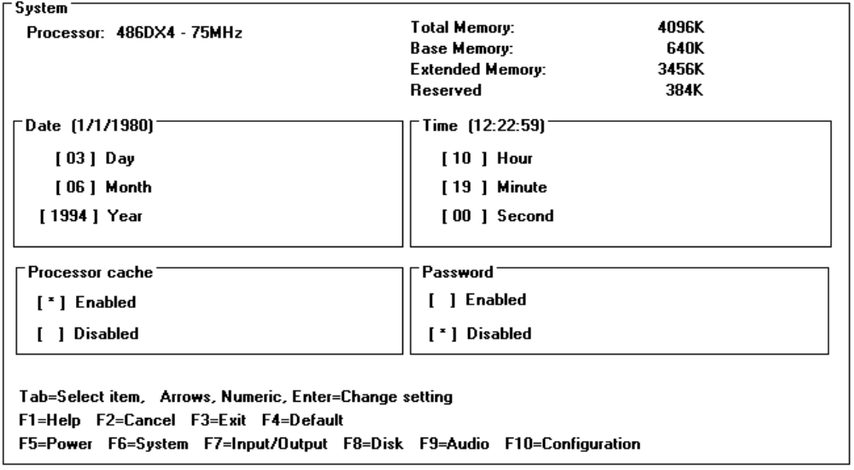
Input/Output Configuration

Setting: | Parameters: | Default: | Comments
Printer port | Bi-directional; EPP; ECP | Bi-directional
IR Port Assignment | COM2 | COM2 | IR is hard wired to COM2
Pointer device | Internal; External | Internal
External Fn. key | Enabled; Disabled | Enabled
Display | LCD; CRT; LCD and CRT | LCD
LCD gray scale | 8, 16, 64 | 64.00 | Dimmed with color display attached
Display mode | Normal;Inverse | Normal | Dimmed with color display attached

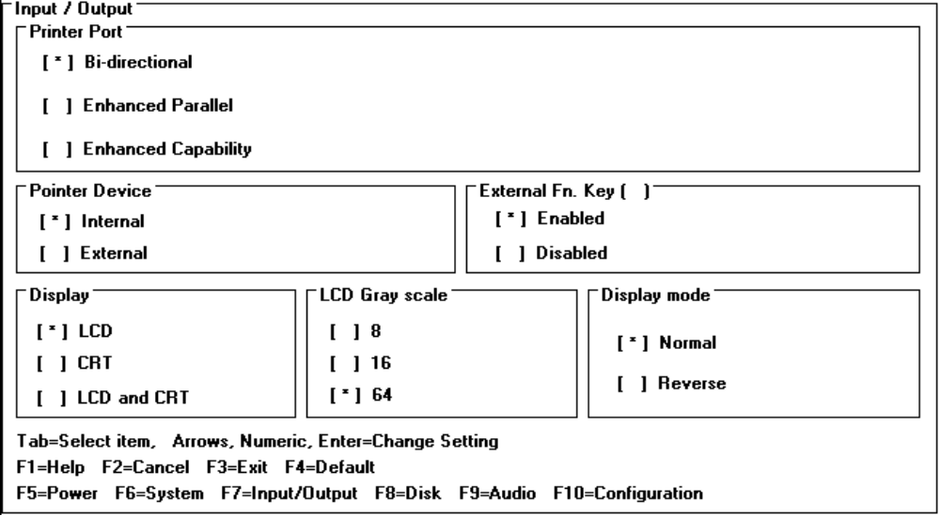

Disk Configuration

Setting: | Parameters | Default | Comments
Diskette A | Enabled; Disabled | Enabled
Boot from | FDD first; HDD only | FDD first
HDD Configuration | Auto; User defined | Auto

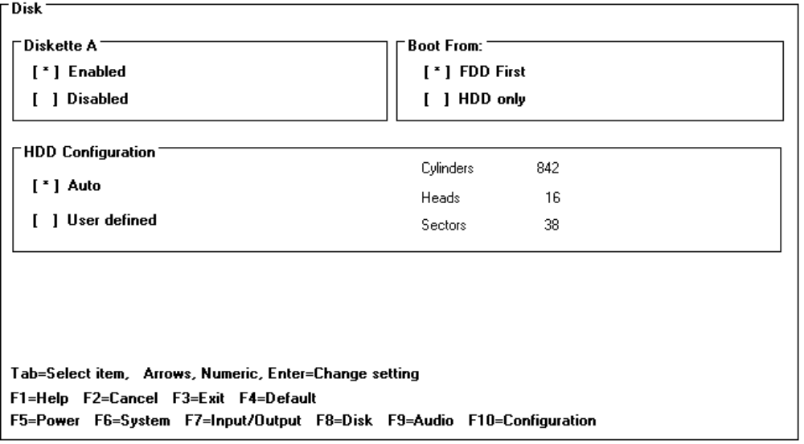
Audio Configuration

The audio screen allows the user to adjust the speaker volume of the system. The user can also select the IRQ, I/O Address and DMA channel of the audio board.

Setting: | Parameters | Default | Comments
Volume Left | Slider | Middle
Volume Right | Slider | Middle
IRQ | IRQ5; IRQ7; IRQ9; IRQ10 | IRQ7
DMA channel | DMA0; DMA1; DMA3 | DMA1

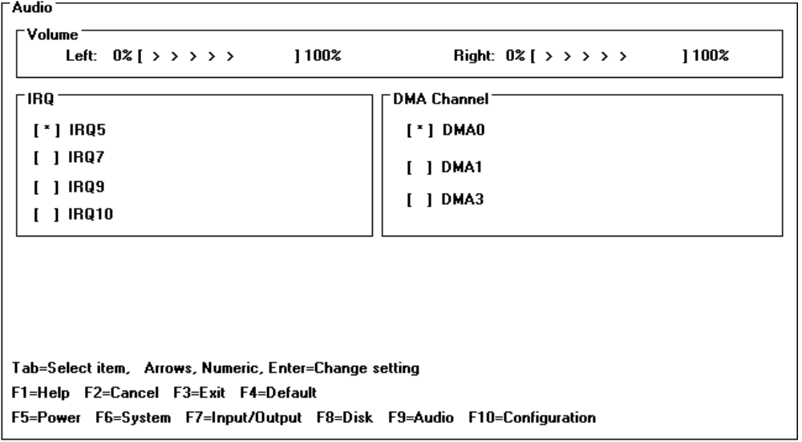
Troubleshooting and Repair
Known Hardware Issues | The OmniBook 4000C and CT will not charge the batteries while in "ON" mode.
 | Certain HP Vectra PCs will not link over I/R with the OB 4000. Refer to the technical newsletter for details.
OmniBook Self-Test | The complete self-test procedure is documented in the OmniBook 4000 Operating Guide.
A note about interpreting self-test results.
Self-test alone should not be used to diagnose a hardware problem. If the self-test results are absolutely clear and repeatable, confirm the results with at least two other non-self-test failure symptoms.
 | The OmniBook 4000 BIOS includes a POST facility that tests a number of hardware and firmware items in the unit at each cold-start (BOOT or RESET).
First POST: BEEP CODES | These multiple beep codes indicate a failure in a simple test of:
 | a portion of base memory
 | Flash BIOS checksum
 | a portion of conventional memory
 | a portion of extended memory
If the unit fails to boot:
all accessories are removed, including memory cards, external floppy, port expander, modems, PCMCIA cards, LAN cards, printers, VGA-out cables, external pointing devices, clean AC power is provided (no "chained" battery chargers or auto adapters), and press reset.
If the unit still fails to boot, it requires service.
Beep codes
Beep codes are used to identify a POST error that occurs when the screen is not available. Once the screen is operating, diagnostic messages are reported to the screen. There are beep codes for both fatal and nonfatal system board errors.

Beep Code | Description
none | CPU register test in progress or failure.
1-1-1 | CPU Failure
1-1-3 | CMOS write/read test in progress or failure. Failure will result in a system halt.
1-1-4 | ROM BIOS checksum test in progress or failure. Failure will result in a system halt. Checksum test - All of the values in a given range of locations are added together. The range includes a location which, when added to sum of the ranges, will produce a known result (0). BIOS is in FLASH and can only be fixed through replacement of the flash device (not a field repairable item) Customer units should be returned for repair.
1-2-1 | Programmable interval timer 0 test in progress or failure. Failure will result in a system
1-2-2 | DMA channel 0 address and count register test in progress or failure. Failure will result in a system halt.
1-2-3 | DMA page register write/read test in progress or failure. Failure will result in a system halt.
1-3-1 | RAM refresh verification test in progress or failure. Failure will result in a system halt.
1-3-2 | SMI RAM Bad. Failure will result in a system halt.
none | First 64K RAM test in progress. No specific test is performed - just indicates that the test is beginning (i.e., no failure).
1-3-3 | First 64K RAM chip or data line failure, multi-bit. Failure results in a system halt.
1-4-2 | Parity failure first 64K RAM. Failure results in a system halt.
2-1-1/2/3/4 | First 64K RAM chip or data line failure on bit x. Failure results in a system halt.
2-2-1/2/3/4
2-3-1/2/3/4
2-4-1/2/3/4
3-1-1 | Slave DMA register test in progress or failure. Failure results in a system halt.
3-1-2 | Master DMA register test in progress or failure. Failure results in a system halt.
3-1-3 | Master interrupt mask register test in progress or failure. Failure results in a system halt.
3-1-4 | Slave interrupt mask register test in progress or failure. Failure results in a system halt.
3-2-4 | Keyboard controller test in progress or failure. Failure results in a system halt.
3-3-4 | Screen memory test in progress or failure. Failure will result in a beep code but not a system halt.
3-4-1 | Video Retrace Failure.
3-4-2 | Screen retrace test in progress.
3-4-3 | Screen retrace test failure
4-2-1 | Timer-tick interrupt test in progress or failure. An error message is displayed on the screen. The system does not halt.
4-2-2 | Shutdown test in progress or failure. If possible, the BIOS will continue POST, skipping the memory tests.
4-2-3 | Gate A20 failure. An error message is displayed on the screen and the memory tests are suspended. The system does not halt.
4-2-4 | Unexpected interrupt in protected mode. The system does not half when an unexpected interrupt occurs.
4-3-1 | RAM test of memory above 64K in progress or failure. POST will continue.
4-3-2 | Programmable interval timer channel 2 test in progress or failure. POST will continue.
4-3-4 | Real-time clock text in progress
4-4-1 | Serial port test in progress or failure. POST will continue.
4-4-2 | Parallel port test in progress or failure. POST will continue.
4-4-3 | Math coprocessor test in progress or failure. POST will continue.

Last POST: DISPLAY CODES | There are a number of POST tests that are performed after the BEEP Code tests. Failure of one or more of these tests will result in a displayed failure code (i.e., 03044). It is extremely important not to interpret a failure code immediately as a hardware failure until:  all accessories are removed, including memory cards external floppy, port expander, modems, PCMCIA cards, LAN cards, printers, VGA-out cables, external pointing devices, clean AC power is provided (no "chained" battery chargers or auto adapters), and press reset.  If the unit still fails to boot, it requires service.  NOTE: make sure the display is adjusted to be visible.

PhoenixBIOS POST Messages (Power On Self Test) | Within POST, there are three kinds of messages:  Error messages: These messages appear when there is a failure in hardware, software, or firmware.  Informational messages: These messages provide infon-nation to the user but require no action.  Beep codes: This kind of warning sounds when POST errors occur and the screen is not available.
 | Because the OmniBook cannot be repaired by a service center below the FRU level, these messages will provided limited troubleshooting or repair information. However, the support specialist and service technician will be able to identify trends in repairs from these codes.

Message | Possible Cause
Diskette drive failure | The 0 or 1 drive failed or is missing.
Diskette drive x failure where x=O or x=1 | The designated drive has either failed or is missing.
Diskette read failure - press Fl to retry boot (or may also say, press Fl to retry boot, F2 for SETUP utility) | The diskette is either not formatted or is defective.
Display adapter failed; using alternate | The color/monochrome switch is set incorrectly. The primary video adapter failed.
Gate A20 failure | The keyboard controller is not accepting commands, specifically, the enable and disableA20 commands.
Fixed disk configuration error | The specified configuration is not supported or doesn't match the actual hardware
Fixed disk controller failure | The controller card has failed.
Fixed disk failure | The fixed disk may be defective.
Fixed disk read failure -press Fl to retry boot (or may also say press Fl to retry boot, F2 for SETUP utility) | The fixed disk may be configured incorrectly or is defective.
Internal cache test failed -cache is disabled | Faulty cache memory in the 80486 processor chip.
Pointer device failure | The mouse failed.
No boot device available -Press Fl to retry boot (or may also say, press Fl to retry boot, F2 for SETUP utility) | Either diskette drive A:, the fixed disk, or both the diskette and disk are defective.
Message | Possible Cause
No boot sector on fixed disk - press Fl to retry boot (or may also say, press Fl to retry boot, F2 for SETUP utility) | The C: drive is not formatted or is not bootable.
Not a boot diskette - press Fl to retry boot (or may also say, press Fl to retry boot, F2 for SETUP utility) | The diskette in drive A: is not formatted as a bootable diskette.
No timer tick interrupt | The timer chip has failed.
xxxxxh Option ROM checksum failure where xxxxxh is the starting address of the option ROM | The peripheral card contains a defective ROM.
Shutdown failure | Either the keyboard controller is not accepting the reset command or the associated reset logic has failed.
Time of day not set - run SETUP program | Clock not set.
Timer 2 failure | The timer chip has failed.
F2 to enter ROM-based SETUP | Invalid configuration information must be changed.
Invalid configuration information - please run SET'UP | Display adapter is configured incorrectly. Memory size is incorrect. Wrong number of diskette drives. Other configuration errors.
Keyboard clock line failure | The keyboard, the keyboard cable connection, or the keyboard controller is defective.
Keyboard data line failure- | The keyboard controller firmware has failed.
Keyboard controller failure | The keyboard controller firmware has failed.
Keyboard stuck key failure | A key is jammed.
Memory failure at hex-value, read hex-value, expecting hex-value | Circuitry associated with the memory chips has failed.
Unexpected interrupt in protected mode | Hardware interrupt or NMI occurred while in protected mode.
Real time clock failure | The RTC or battery failed.
Message | Possible Cause
nnnk Base Memory | The amount of base memory that tested successfully.
nnnk Extended | The amount of extended memory that tested successfully.
Memory tests terminated by keystroke | This message indicates that a user pressed the spacebar while the memory tests were nmning and stopped the memory tests.
Press the Fl key to continue | This message indicates that an error was found during POST. Pressing the Fl key allows the system to attempt to boot.
Beginning memory test Press the SPACEBAR to terminate the memory test | A user can stop the memory tests by pressing the spacebar.
Press the Fl key to continue, F2 to nm the Setup utility | This message indicates that an error was found during POST. Pressing the Fl key allows the system to attempt to boot. Pressing F2 allows users to run the ROM-based Phoenix SETUP utility to correct configuration information.

Appendix A: Part Numbers
Description | HP Part Number | Exchange Part Number
RUBBER FOOT BACK FLAT | F1081-60933 | none
RUBBER FOOT FRONT ROUND | F1081-60934 | none
NAME PLATE FOR ENGRAVING | F1081-60936 | none
PALM REST SCREW FTB 1.7X4L | F1081-60942 | none
MICRO PHONE ASSY | F1081-60946 | none
OVERLAY-BACK PNL | F1081-80004 | none
EXPANSION DOOR | F1081-60930 | none
TRACK BALL ASSY | F1081-60914 | none
PALM REST ASSY | F1081-60915 | none
ICON ASSY FOR PEGASUS | F1081-60916 | none
HOOK BUTTON | F1081-60926 | none
IR LENS | F1081-60927 | none
MEMORY COVER DOOR | F1081-60928 | none
PCMCIA DOOR | F1081-60929 | none
I/O DOOR | F1081-60931 | none
DOOR LATCH EXPANSION & I/O | F1081-60932 | none
MODEL NAME PLATE 4000C | F1081-60937 | none
MODEL NAME PLATE 4000CT | F1081-60938 | none
DISPLAY/CHASSIS SCREW ISOP M2.6x8L | F1081-60939 | none
HDD SCREW ISOP M2.6X4L EXTERN | F1081-60940 | none
HDD SCREW ISOP M3X6L INTERN | F1081-60941 | none
HDD LABEL | F1081-60943 | none
HDD COVER | F1081-60944 | none
HDD LATCH | F1081-60945 | none
THERMAL MOUNTING TAPE | F1081-60947 | none
HARNESS TRACK BALL | F1081-60948 | none
HARNESS SUB BAT-M/B | F1081-60949 | none
INTEL INSIDE STICKER | F1052-80013 | none
HDD SHIELDING | F1081-60950 | none
HDD SHIELDING FOR 260MB | F1081-60951 | none
DISPLAY MODULE DSTN | F1081-60902 | F1081-69002
DISPLAY MODULE TFT | F1088-60901 | F1088-69001
HDD MODULE 260MB | F1091-60901 | F1091-69001
HDD MODULE 340MB | F1092-60901 | F1092-69001
HDD MODULE 520MB | F1093-60901 | F1093-69001
MEM MODULE 4MB | F1076-60901 | F1076-69001
MEM MODULE 8MB | F1077-60901 | F1077-69001
MEM MODULE 16MB | F1078-60901 | F1078-69001
FDD MODULE | F1079-60901 | none
AC ADAPTER | F1072-60901 | none
BATTERY PACK | F1073-60901 | none
KEYBOARD US | F1081-60904 | none
KEYBOARD UK | F1081-60905 | none
KEYBOARD GER | F1081-60906 | none
KEYBOARD SPA | F1081-60907 | none
KEYBOARD FRE | F1081-60908 | none
KEYBOARD ITA | F1081-60909 | none
KEYBOARD SWI | F1081-60910 | none
KEYBOARD DAN | F1081-60911 | none
KEYBOARD NOR | F1081-60912 | none
KEYBOARD SWE/FIN | F1081-60913 | none
PORT REPLICATOR | F1090-60901 | none
AUTO ADAPTER | F1075-60901 | none
DUMMY RAM CARD | F1081-60935 | none
HDD MODULE 810MB | F1132-60901 | F1132-69001
EXTERNAL BATTERY CHARGER | F1074-80003 | none
OB 4000C/CT ENG Rcvy Flpy Dsk | F1081-60953 | none
OB 4000C/CT FRE Rcvy Flpy Dsk | F1081-60954 | none
OB 4000C/CT ITA Rcvy Flpy Dsk | F1081-60955 | none
OB 4000C/CT GER Rcvy Flpy Dsk | F1081-60956 | none
OB 4000C/CT SPA Rcvy Flpy Dsk | F1081-60957 | none
Rcvy CDROM Kt-Mult-Lang 4000C/CT | F1081-12001 | none
Lower Cover | F1081-60958 | none
Upper Case with Button | F1081-60959 | none
LCD Back Cover for TFT | F1088-60902 | none
LCD Front Cover for TFT | F1088-60903 | none
LCD Back Cover for DSTN | F1081-60960 | none
LCD Front Cover for DSTN | F1081-60961 | none
PCB Assy PK-688/PK-AUD | F1081-60962 | none
PCA 50MHZ PROC PK-4D2-50 | F1081-60917 | F1081-69003
PCA 75MHZ PROC PK-4D4-75 | F1081-60952 | F1081-69004
PCA 100MHZ PROC PK-4D4-100 | F1081-60918 | F1081-69005
PCA MAIN W/O CPU PK-486W | F1081-60919 | F1081-69006
PCA IR MOD PK-MIR | F1081-60920 | none
PCA DISPLAY CONNECT PK-LSP | F1081-60921 | none
PCA ASS’Y PK-DC REV:00 | F1081-60922 | none
SUB BATTERY SET | F1081-60925 | none
Conductive Tape 4000 | F1081-80020 | none
HDD Plastic Kit 4000 | F1081-60963 | none
Standoff L=15mm | F1081-60964 | none
Standoff L=10mm | F1081-60965 | none
K/B Grounding Plate | F1081-60966 | none
LSP-M/B Shielding Plate | F1081-60967 | none
CPU Shielding Plate | F1081-60968 | none
Screw ISOB M2x6L | F1081-60969 | none
Screw ISOB M2.6x5L | F1081-60970 | none
OB4000 Familiarization Guide | F1081-90051 | none
Appendix B: Additional Resources

The following table contains resources for additional product related information.

Resource | Number/Address | Comments
HP External Web | http://hpcc998.external.hp.com/mcd/ | No usage restriction
HP-MCD Internal Web | http://webmcd.cv.hp.com | Restricted to HP internet access only
HP MCD Service Engineer | svc-eng_mcd@cv.hp.com | Email address for service related questions and issues

